**Hello World RESTful Web Service**

URL http://localhost:8083/hello in both chrome browser and postman

* In network tab of developer tools show the HTTP header details received

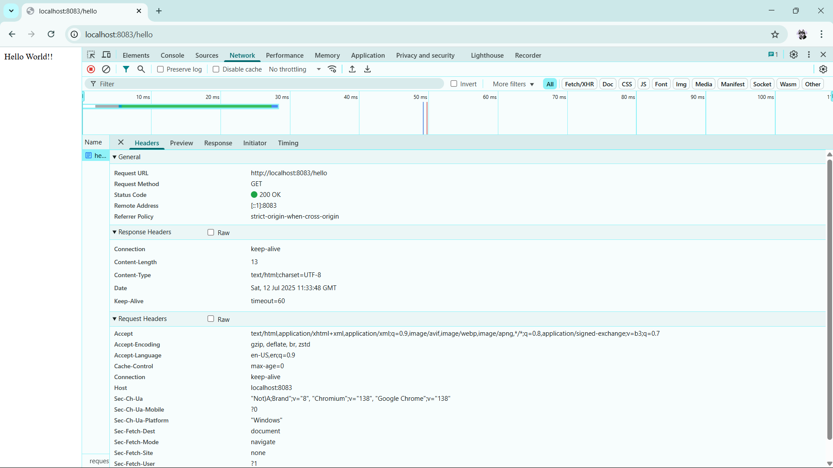

* In postman click on "Headers" tab to view the HTTP header details received

